**What is Tableau?**

Tableau software is one of the fastest growing data visualization tools which is currently being used in the Business intelligence industry.  
It is the best way to change or transform the raw set of data into an easily understandable format with zero technical skills and coding knowledge.

Tableau is basically a data visualization tool which provides pictorial and graphical representations of data.

**What is Tableau used for?**

Usage of Tableau software are listed below:

* Tableau software is used to translate queries into visualization.
* It is also used for managing metadata.
* Tableau software imports data of all sizes and ranges.
* For a non-technical user, Tableau is a life saver as it offers the facility to create ‘no-code’ data queries.
* Ever since it was introduced, this data visualization tool is used for Business Intelligence industry. Organizations like Amazon, Walmart, Accenture, Lenovo, and so on widely use Tableau.

**Public Grievance Analysis**

The dataset which we used is public grievance 2016-2019. Which includes Monthly Department-wise public grievance receipts and disposals through CPGRAMS survey results. We have derived the following visualizations from the given data.

**Visualization 1:**

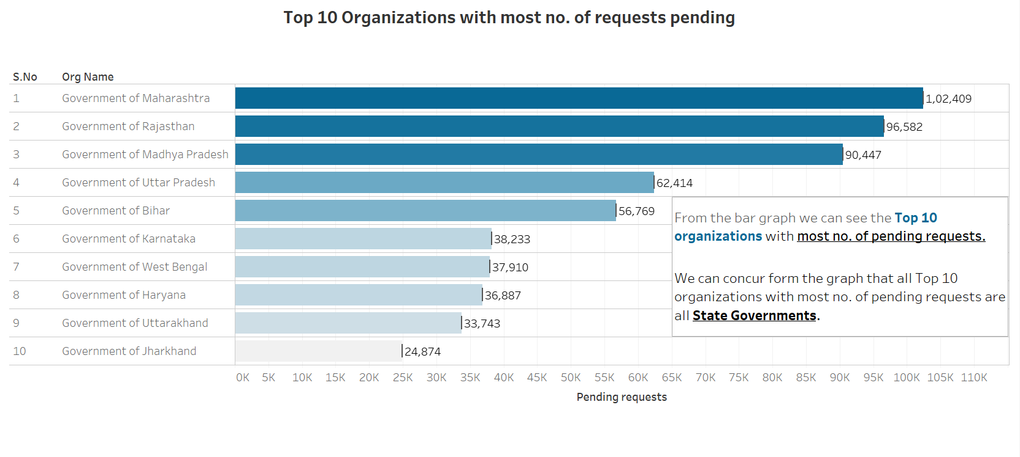

1. **CHART NAME:** Top 10 Department/ Ministries with the most pending receipts

2. We have chosen a **Bar graph** for showing the top 10 Department/ Ministries with the most pending receipts. We chose it because it will be easier for the audience to compare the data from department which have most no. of pending cases.

3. **Gestalt principles used**

1. **Gestalt law of proximity:** No. of grievances pending by each department is shown next to the respective bars in the graph
2. **Gestalt law of continuity:** The data is arranged in descending order (high to low) to show that the elements are related and the audience get an idea of the data flow
3. **Gestalt law of focal point:** The department with maximum no. of pending requests is highlighted in a separate colour to capture the audience’s attention
4. **Gestalt law of closure:** From the graph the user gets the idea of the data shown i.e., top 10 Department/ Ministries with the most pending receipts in a single recognizable pattern.
5. **Preattentive attributes used**
6. **Color:** Gradient color is used to show pattern and makes user understand that darker the color, more the number of pending request in the department.
7. **Length (Form)**: It gives quantitative information. It is used for comparing the pending request in different department.
8. **Orientation (Form):** It is used to grab user attention to different organization in the data set.

**Visualization 2:**

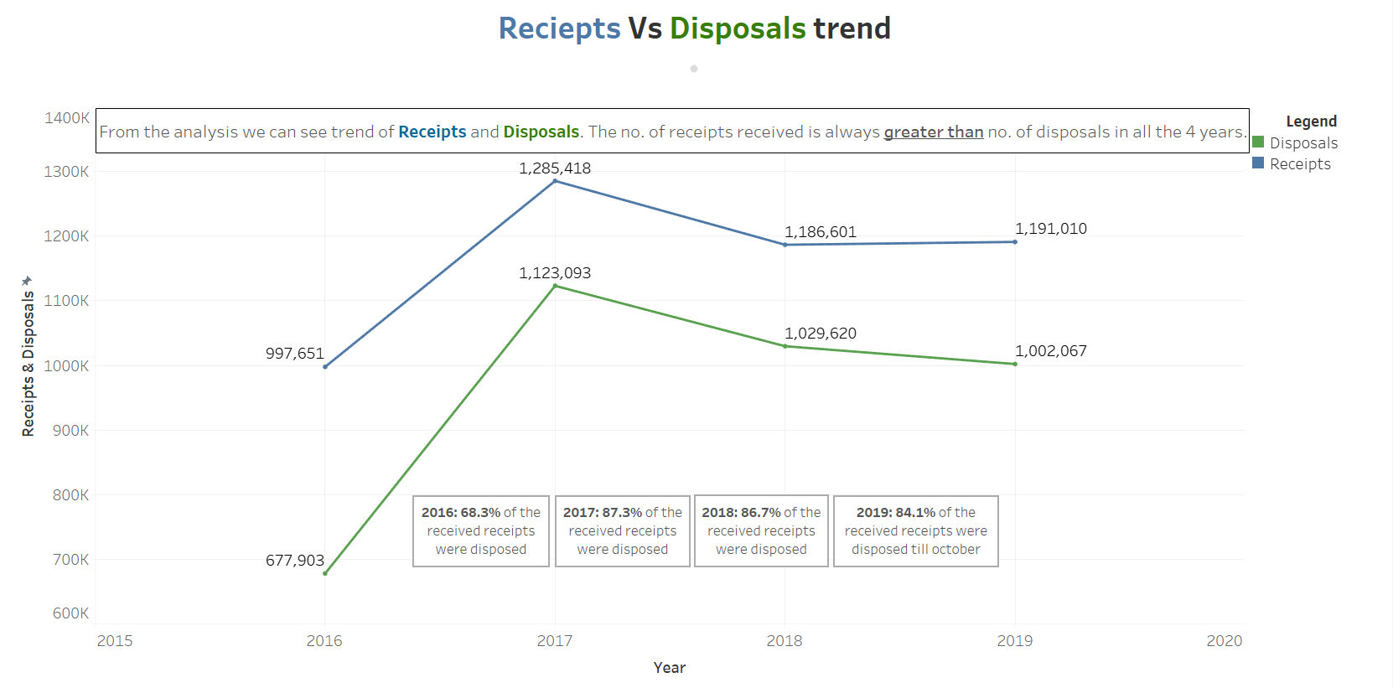

1. **CHART NAME:** Receipts Vs Disposals trend

2. The **Line graph** depicts the trend of receipts received Vs. the receipts disposed between Jan 2016 and Oct 2019. We chose line graph as it gives an idea to the audience on how the disposals are lagging behind receipts between 2016-2019.

3. **Gestalt principles used**

1. **Gestalt law of similarity:** both receipts and disposals have a similar pattern.
2. **Gestalt law of connection:** The elements are connected to each other using lines and are perceived as a single unit .
3. **Gestalt law of focal point:** The no. of receipts and disposals are displayed for each year. The percentage of receipts processed is also shown
4. **Gestalt law of closure:** From the graph the user gets an understanding of the receipts Vs. disposal trend between 2016 – 2019. The disposals are lagging behind receipts each year

4.**Pre attentive attributes used**

1. **Color:** Gradient color is used to show pattern and help user to distinguish receipts and disposal.
2. **Size (Form):** same size lines are used for receipts and disposals
3. **Curvature (form):** we can see the shape and curvature of the receipts and disposal line. They follow similar pattern throughout the 4 years

**Visualization 3**

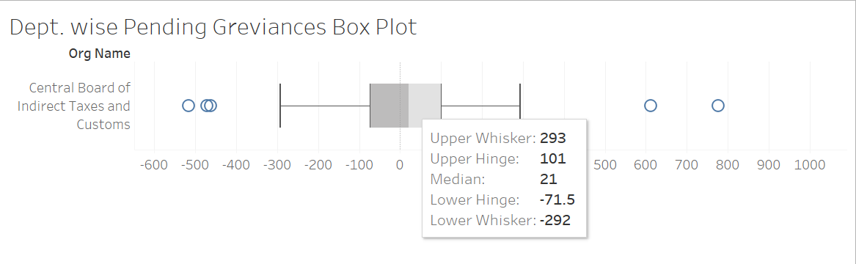

1. **CHART NAME:** Dept. wise Pending Grievances Box Plot

2. The **Box Plot** is used to find the upper & lower whisker, hinges and median for each department. These values can be used in the future for doing deep analysis and calculations.

3. **Gestalt principles used**

1. **Gestalt law of proximity:** all the whiskers, hinges, median and other calculations for an organization are grouped together into a single box plot
2. **Gestalt law of continuity:** The data is arranged in ascending order which can be seen from the x-axis values
3. **Gestalt law of focal point:** The whiskers and hinges are indicated by blue circles making the user to focus on them
4. **Gestalt law of closure:** The user can understand the data using the upper bound, lower bound, median values which are displayed to him by tableau.

4. **Pre attentive attributes used**

1. **Hue (Colour):** the box plot is shaded with two colours to differentiate between lower and upper ranges.
2. **Shape (Form):** Box shape is used to denote box plot

**PUBLIC GRIEVANCES ANALYSIS DASHBOARD**

